

AMERICAN INTERNATIONAL UNIVERSITY-BANGLADESH (AIUB)

Faculty of Engineering

Bachelor of Science in Electrical and Electronic Engineering (EEE) BAE 2101: Computer Aided Design and Drafting

Experiment # 03: Familiarization with different orthographic projections and drawing using AutoCAD software.

**Objective:** To familiarize the students with the different orthographic view and draw the orthographic view using AutoCAD Software.

Example 3.1: Draw the given orthographic projection (dimensions are in INCH)

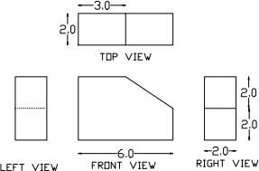

Figure 3.1: Orthographic projection

Example 3.2: Draw the given orthographic projection (dimensions are in FEET)

TOP VIEW

LEFT SIDE VIEW

FRONT VIEW

RIGHT SIDE VIEW

Figure 3.2: Orthographic projection

Example 3.3: Draw the given orthographic projection (dimensions are in INCH)

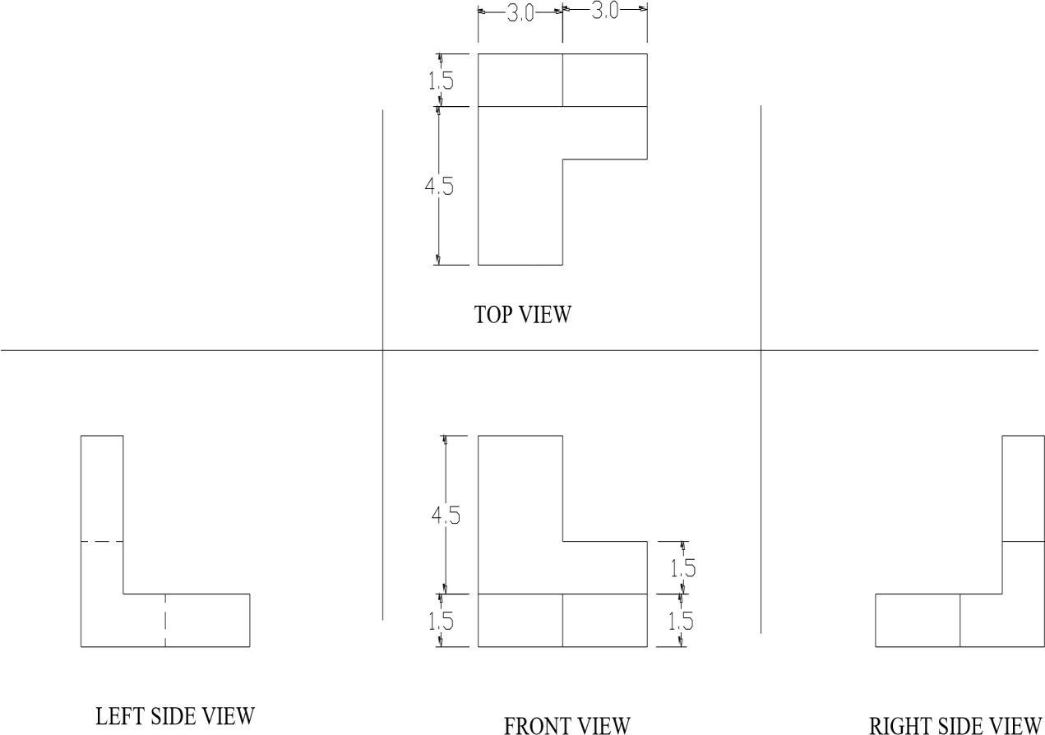

Figure 3.3: Orthographic projection

Example 3.4: Draw the given orthographic projection (dimensions are in INCH)

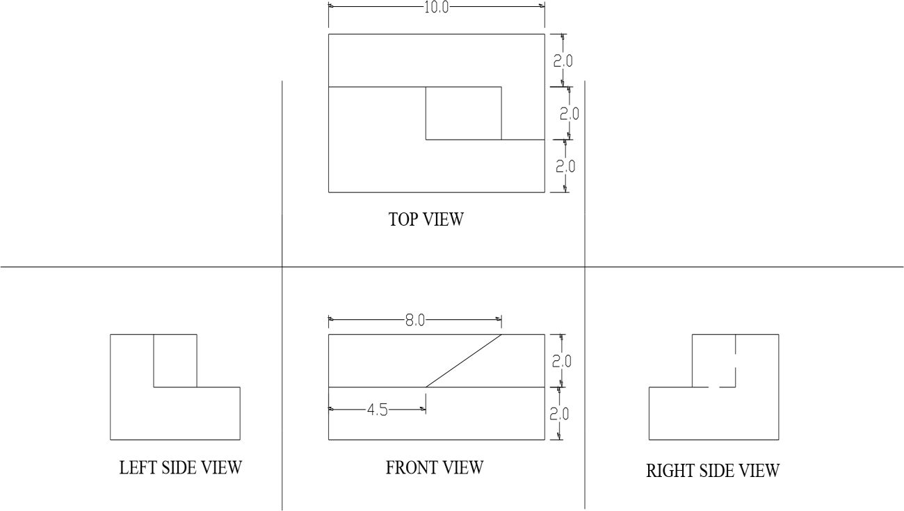

Figure 3.4: Orthographic projection

Example 3.5: Draw the given orthographic projection (dimensions are in INCH)

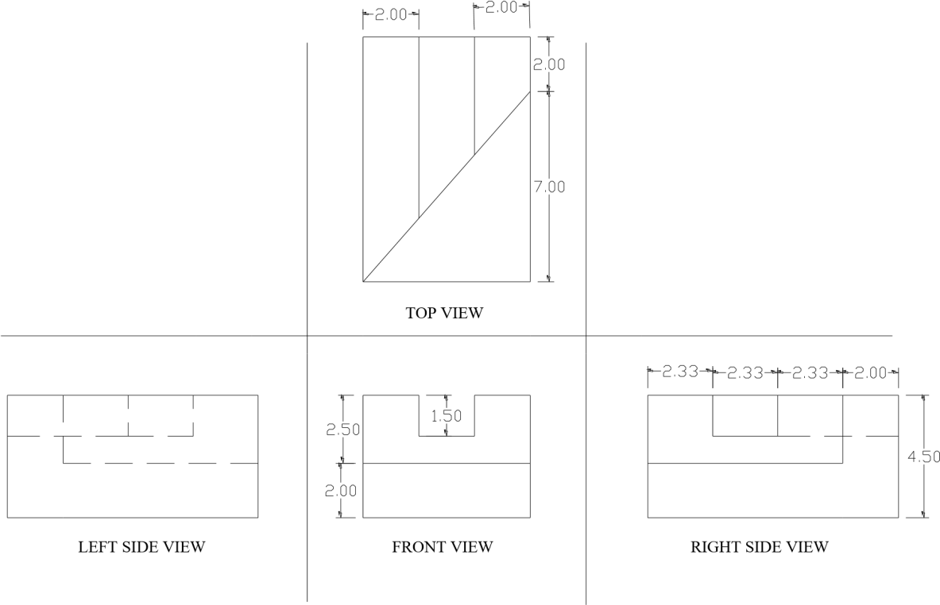

Figure 3.5: Orthographic projection

Example 3.6: Draw the given orthographic projection (dimensions are in FEET)

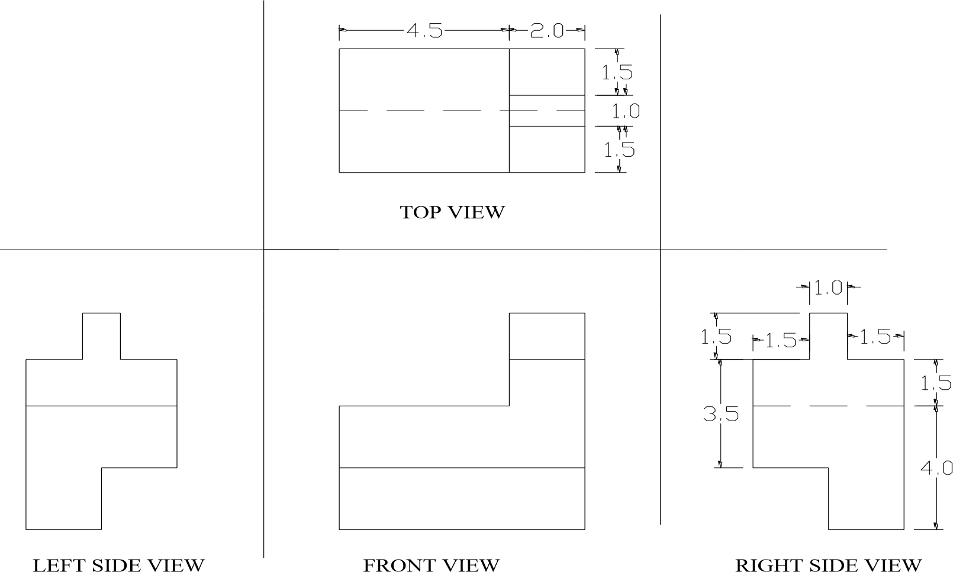

Figure 3.6: Orthographic projection

***Reference***

1. David Byrnes and Mark Middlebrook, “AutoCAD 2007 For Dummies”.
2. Jeyapoovan T, “Lesson Plans for Engineering Graphics”.